**WORK INSTRUCTIONS *TRO-TOOL\***

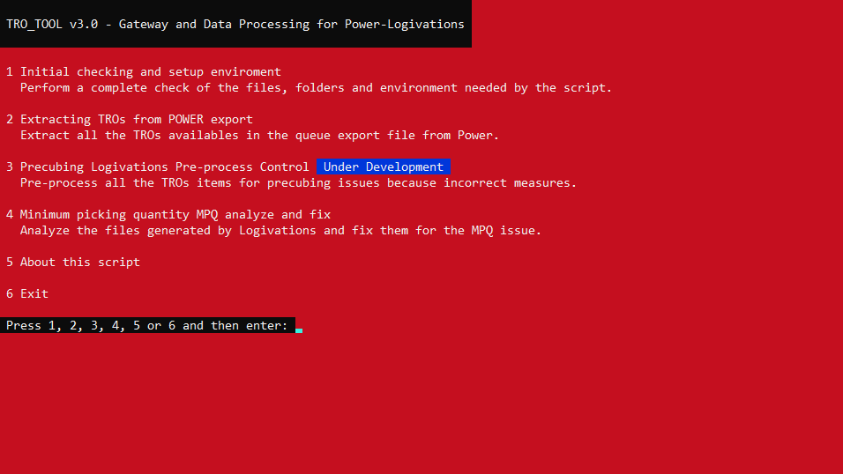

|  |  |
| --- | --- |
| **TOOLS** | Laptop / Computer |
| **RELEASES** | **V3.0 – 06/09/21**  First final version release with complete TRO extraction from power without filters to a single file separated by TRO. MPQ Minimum Pick Quantity detection and solution for files generated by Logivations.  **V3.1 – 23/09/21**  Improved extraction TROs from power, now the tool extract all the types in different files, but also one with all the types together. Improved renaming of files, now the files will include a time stamp in the file name so if we process the same TRO twice (same TRO at different time, same TRO with different type… we can keep a control of it) |
| **GENERAL INFO** | TRO_TOOL is a batch script for Windows OS developed with the aim of help, detect and correct possible issues during the MO creation process, the script has been protected to prevent its unauthorized modification and requires the following files for its operation:   * **POWUploadConfigDetail.txt** This file contains all the information needed by the script to detect the MPQ minimum pick quantity issue. You can obtain/download this file from POWER reports. *Reports > Report ID 72717 > POWUploadConfigDetail > Print > Export > DefaultFilter* * **POWER Queue OUT OL export.txt** This file is the complete queuegroup export from POWER and the script will be use it to extract all the TROs available for creating multi orders thru Logivations. *Operation Overviews > QueueGroup > Actions > Tour Building > Export Queues* * **POWER Item SKU export.txt (**under development, not really needed by now**)** This file contains the complete item SKU list to analyse measures and inconsistencies between inners and outers *Operation Overviews > QueueGroup > Actions > Tour Building > Export Item Info*   You can download the latest version of the script from: |

|  |  |
| --- | --- |
| **PROCEDURE** | 1. TRO_TOOL will generally be compressed into a ZIP file, please unzip the file into a LOCAL folder like Desktop, Documents, Downloads… IMPORTANT at the moment this script only works with local files environment, not network drives. 2. Once the file has been unzipped, a folder tree will have been generated. If this is not the case, the script will detect that the necessary folders do not exist and will create them itself.     1. **Import To Logivations** Here all the TROs extracted from the POWER Queue OUT OL export.txt file will be stored, ready to be processed by Logivations.    2. **Import To Power** Here we will save all the reports and files generated by Logivations to be processed by the script and ready to upload to Power.    3. **Logs** In this folder, we will keep a log with the MPQ issues found.    4. **Temp** Folder used by the script to store information and temporary files that it will need. 3. Running the script the first time  It is possible, due to the level of restriction on computer equipment, that the first time we run the script it will show us a warning message like this.  Please, no panic, this is a normal message. Just make sure that the script has been downloaded from a safe place, if you have questions, or you are not sure, please contact us.  To continue, click on "more info" and then click on a new button that will appear labeled "Run anyway" 4. **Script main menu**    This is the screen and the main menu of the script. The first thing we will have to do is a check and start-up of the entire environment that the script needs. Option 1 in the menu. We recommend that whenever the script is used for the first time, this step is carried out.     The script will inform us of all the files we need so that we can use it without problem.   The folder and file tree should look something like this.   If we rerun option 1 of the main menu, we would now get the following screen, since now we have all the files and folders necessary to start using the script.   Now we can start using the script 5. **Extracting TROs from POWER export (Option 2)** If we have downloaded the file "POWER Queue OUT OL export.txt" from Power, we can perform the extraction of TROs, simply use option number 2 from the main menu, and the script will detect the available TROs and extract them in the folder “Import To Logivations”     Once this process is done, you can start to process all the TROs with Logivations 6. **Minimum picking quantity MPQ analyze and fix (Option 4)** One of the major reasons of the existence of this script is the ability to detect when an item has been separated below its minimum pick quantity, or the result is not a multiple of this number. For this we will need the reports / files "Queue groups with case types.csv" generated by Logivations to be analyzed and that we will have to store in the "Import To Power" folder. *Reports > Other reports > Queue groups with case types > Recalculate report > Export > Download*     Once we have processed the TROs by Logivations, generated the "Queue groups with case types.csv" files and saved them in the "Import To Power" folder, we are ready to detect and fix the MPQ issue.      The script will detect the TRO and rename the file appropriately and report if there is no MPQ issue. From now on, the file generated by the script could be imported into Power into Power.  If the script detects that there is an MPQ issue, it will display it as follows, and will generate several additional files.       In this case, having detected an issue of MPQ, the files that should be uploaded to power to avoid this error in the picking process are those with the tag "fixed". |
| **FORBIDDEN** | **It is strictly forbidden during work to:**   * **Use smartphones** * **Use earbuds** * **Smoke** * **Take passengers with you on machines** * **Have a backpack with you** * **Create open fire & flame** * **Walk beneath forks** * **Ride on transpallets** * **Use alcohol/drugs** |